衛生福利部國民健康署「罕見疾病個案通報審查基準機制」(送審資料表)
-特發性或遺傳性肺動脈高壓
[Idiopathic or Heritable pulmonary arterial hypertension, IPAH or HPAH] -
1. □臨床症狀及徵兆之病歷紀錄，需包含病史、個人史及用藥史等(必要)
2. □心臟超音波及心導管檢查正式報告或影本，並具有肺動脈壓的數據(必要)
3. □排除次發性肺動脈高壓相關原因之檢驗報告及佐證資料(必要)
4. □與本疾病相關之正式入院及出院病歷摘要(必要)
5. □如為遺傳性或基因變異疾病，應檢附詳細家族史與相關基因檢測報告(選擇)
6. □其他檢查均需附上正式報告或影本
7. □需附上相關影像資料
項目 | 填寫部分
病史(必要)  (History) | Symptoms : (Duration, Times or Frequency)  □ Dyspnea  □ Fatigue  □ Syncope  □ Chest Pain  □ Peripheral edema  Personal history:____________________________________  Medications:____________________________________________
身體檢查(必要)  (Physical examination) | □ Right ventricular heave □ Clubbing fingers  □ Loud P2 □ Hepatojugular reflux  □ Peripheral edema □ Ascites  □ High jugular venous pressure  □ 心雜音  舒張期Gr. /VI at  收縮期Gr. /VI at
胸部X光(必要)  (Chest X-ray) | □ Enlarged pulmonary artery  □ Enlarged right ventricle
心電圖(必要)  (ECG) | □ Right axis deviation  □ Right ventricular hypertrophy  □ Peaked P-wave  □ Other
肺功能檢查(必要)  (Pulmonary function test) | □ Standard spirometry  □ DLCO (Diffusing capacity of the lung for carbon monoxide)
經胸心臟超音波(必要)  (Transthoracic echocardiography) | TR velocity ≥2.8 m/s, 2-D and Doppler indices of pulmonary hypertension (PH) (if needed)
實驗室數據(必要)  (Laboratory data) | □ Complete blood count, aPTT, PT  □ LFT : AST , ALT , Bilirubin  total protein , Albumin , others  □ BUN , Creatinine , Na , K  □ Arterial blood gas:  PaO₂: PaCO₂:  □ Thyroid function test:  TSH: free-T4 or [TSH: T4: T3: ]  □ HIV Ab: □ Positive(+) □ Negative(-)
肺部通氣灌流掃描(必要)  (Lung perfusion & ventilation scan) | □ Negative(-) □Positive(+):
胸部電腦斷層(含顯影劑)(必要)  (Chest HRCT) | □ Negative(-) □Positive(+):
腹部超音波(選擇)  (Abdominal ultrasound) | □ Negative(-) □Positive(+):
自體免疫相關檢驗及會診免疫風濕科(必要)  (Autoimmune profile and rheumatology consult) | □ ANA:  □ Anti-Scl70:  □ Anti-RNP:  □ C3: C4: RF:
右心導管及血管反應度測試(必要) (Right Heart catheterization and vasoreactivity test) | PAP(S/D/M) : / / mmHg  RAP : / / mmHg  PAWP*: / / mmHg  C.O. : L/min  C.I. : L/min/m²  PVR: Wood units, or PVRI: Wood units·m2  □ acute vasoreactivity :  □ Negative(-) □ Positive(+):
基因檢測(選擇) | - □BMPR2  - □其他：______________
特殊狀況 | 若臨床表現具有共病者，請附說明書及相關基因檢測，闡明其可能之致病機轉(causal attribution)。
主要參考文獻：European Respiratory Journal 2024 64(4): 2401324
Abbreviation:
*Pulmonary arterial wedge pressure (PAWP)或 Pulmonary capillary wedge pressure (PCWP) 或 Left atrial pressure (LAP)

衛生福利部國民健康署「罕見疾病個案通報審查基準機制」(審查基準表)
-特發性或遺傳性肺動脈高壓
[Idiopathic or Heritable pulmonary arterial hypertension, IPAH or HPAH] -
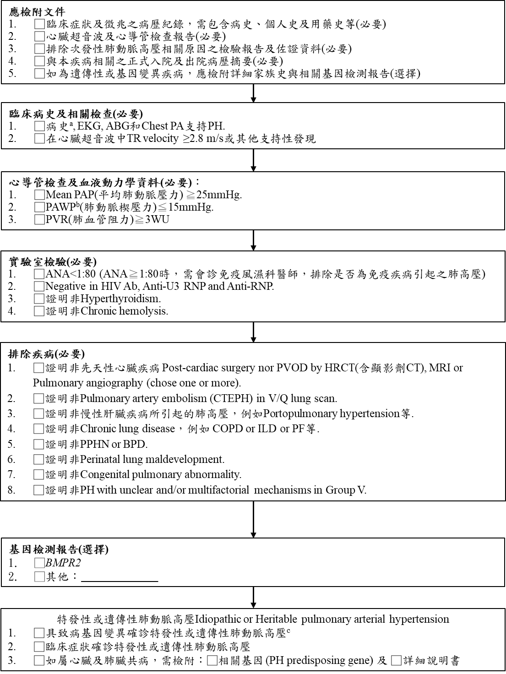
主要參考文獻：European Respiratory Journal 2024 64(4): 2401324.
備註：
a: 症狀包括 dyspnea, syncope, chest pain, peripheral edema, fatigue.
b: Pulmonary arterial wedge pressure (PAWP)或Pulmonary capillary wedge pressure (PCWP)或Left atrial pressure (LAP)
c:含詳細病史, 心臟超音波檢查, magnetic resonance imaging (MRI), Pulmonary Function Tests (PFTs), Diffusing Capacity of the Lung for Carbon Monoxide (DLCO), high resolution CT (HRCT), 排除 Interstitial Lung Disease (ILD)
Abbreviation:
EKG: Electrocardiogram. ABG: Arterial Blood Gas. Chest PA: Chest Posteroanterior view. TR velocity: Tricuspid Regurgitation velocity. Mean PAP: Mean Pulmonary Artery Pressure. PAWP: Pulmonary Artery Wedge Pressure. PVR: Pulmonary Vascular Resistance. ANA: Antinuclear Antibody. HIV Ab: Human Immunodeficiency Virus Antibody. Anti U3 RNP: Anti U3 Ribonucleoprotein Antibody. Anti RNP: Anti Ribonucleoprotein Antibody. PVOD: pulmonary veno-occlusive disease. HRCT: high resolution CT. MRI: Magnetic Resonance Imaging. CTEPH: chronic thromboembolic pulmonary hypertension. COPD: chronic obstructive pulmonary disorder. ILD: Interstitial Lung Disease. PF: pulmonary fibrosis. PPHN: Persistent pulmonary hypertension of newborn. BPD: Bronchopulmonary Dysplasia. Group V: in clinical classification of PH in 2024 (表一、肺高血壓分類).

